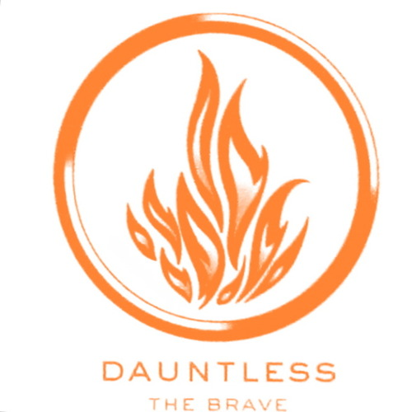
Horoscope:
You are tough on the outside but have a constant battle with the demons inside of you. You care a lot about your friends and would take a bullet for them. You care too much to a fault. You will never be content in a relationship until you learn to love yourself first. Some rumors that are completely untrue will be said about you. You will have to use your inner strength to stay calm and focus on the people around you who care about you and the things that are important in life. You will be extremely successful in life as long as you do not confuse bravery with recklessness.
Tarot Card:
Upright: Inner Strength, Bravery, Compassion, Focus
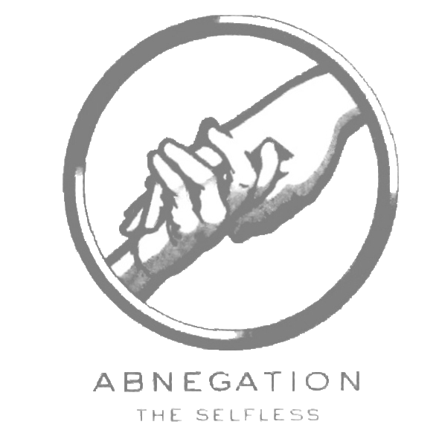
Horoscope:
You care more about other people than yourself and always put their needs before yours. You are extremely loyal to your friends and loved ones. You will make many sacrifices throughout your life for the people you love at a cost to your own happiness. This will cause problems for you. You will have problems with your mental health because you never focused on your own problems. However, time will heal all wounds for you. You will get married and raise your family to value being selfless just as you were taught by your parents.
Tarot Card:
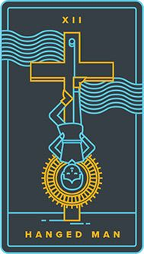
Upright: Sacrifice, Release, Martydrom
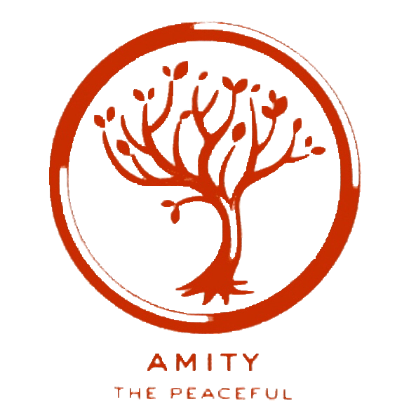
Horoscope:
You will live an incredibly happy and peaceful life. You will find your significant other early on in life. You will love your job and hardly ever complain about it. Someone close to you will be hurting deeply and you will not be aware of it until it is too late. You will not feel completely fulfilled until you gain new perspectives. Go back and reread old books and then read new ones to get a different worldview. You will live in harmony with your neighbors and die with many people who loved and cared about you.
Tarot Card:
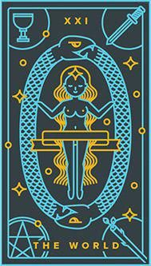
Upright: Fulfillment, Harmony, Completion
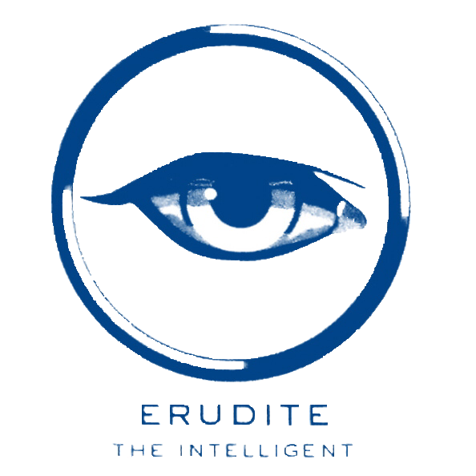
Horoscope:
You will invent something groundbreaking in your lifetime. You will put a lot of time and energy to your studies. There will be temptations to get yourself hanging around the wrong crowd that you will have to fight. You will desire to have an impact on the world in some way with your new discoveries. You will not have much of a social life and marriage or kids will not be a priority to you. You will manifest a lot of good things for yourself if you continue to have a good work ethic.
Tarot Card:
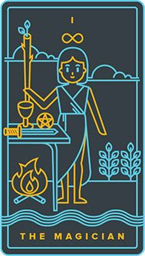
Upright: Willpower, Desire, Creation, Manifestation

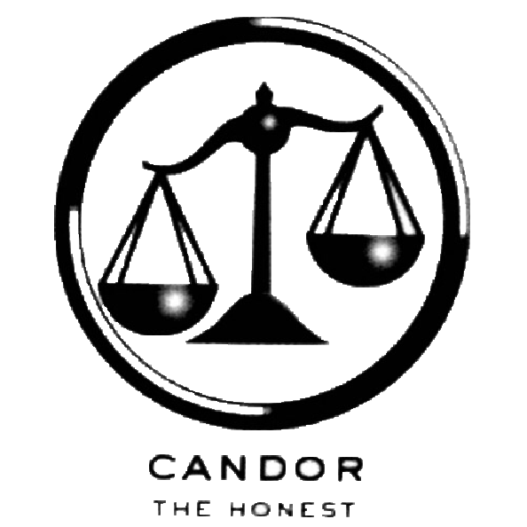
Horoscope:
You will not have a filter and will not be able to control anything that comes out of your mouth. You will be passionate about many things and fight for what you believe in and what you believe is right. You will believe in karma and that good things will happen to good people such as yourself. You will hurt a few loved ones with your brutal honesty. It will be hard for you to trust people outside of your faction. You may become paranoid and think that many people dislike you because of your honesty.
Tarot Card:
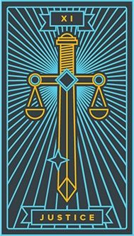
Upright: Cause and Effect, Clarity, Truth

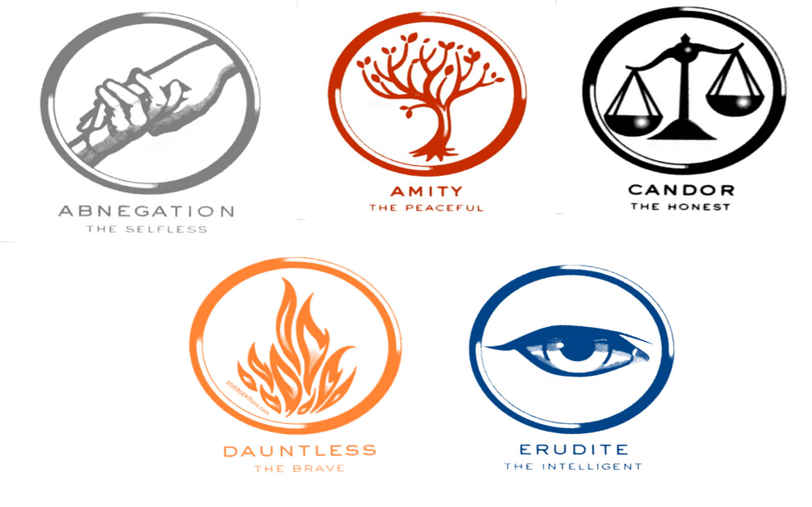
Horoscope:
You will live in fear your entire life since Divergent’s are killed for people not understanding them. You will never find yourself and figure out who you truly are as a person if you let what others think about you control how you act. You may struggle with addiction as you are struggling to find where you belong. The people you surround yourself with will be people that you are trying to help and fix. This will hurt you in the long run since people will not change if they do not want to. You will end up with someone who shares a lot of similar struggles as you do and find comfort in them.
Tarot Card:
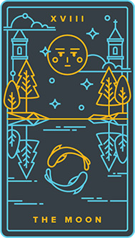
Reversed: Confusion, Fear, Misinterpretation

